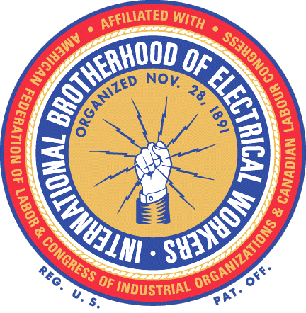
T
®

35 things your company cannot do when you try to organize a union

- Attend any union meeting, park across the street from the hall, or engage in any undercover activity which would indicate that the employees are being kept under surveillance to determine who is and who is not participating in the union program.

- Tell employees that the company will fire or punish them if they engage in union activity.

- Lay off, discharge, or discipline any employee for union activity.

- Grant employees wage increases, special concessions, or benefits in order to keep the union out.

- Bar employees in support of the union from soliciting employees’ memberships on or off the company property during non-working hours.

- Ask employees about union matters, meetings, etc. (Some employees may, of their own accord, walk up and tell of such matters. It is not an unfair practice to listen, but to ask questions to obtain additional information is illegal.)

- Ask employees what they think about the union or a union representative.

- Ask employees how they intend to vote.

- Threaten employees with reprisal for participating in union activities For example, threaten to move the plant or close the business, curtail operations or refuse employee’s benefits.

- Promise to increase benefits to employees if they reject the union.

- Give financial support or other assistance to a union.

- Announce that the company will not deal with the union.

- Threaten to close, in fact close, or move a plant in order to avoid dealing with a union.

- Ask employees whether or not they belong to a union, or have signed up for union representation.
- Ask an employee during the hiring interview about their affiliation with a labor organization or how they feel about unions.

- Make anti-union statements or act in a way that might show preference for a nonunion employee.

- Make distinctions between union and nonunion employees when assigning overtime work or desirable work.

- Purposely team up nonunion employees and keep them apart from those supporting the union.

- Transfer workers on the basis of union affiliation or activities.

- Choose employees to be laid off in order to weaken the union’s strength or discourage membership in the union.

- Discriminate against union people when disciplining employees.

- By nature of work assignments, create conditions intended to get rid of an employee because of his union activity.

- Fail to grant a scheduled benefit or wage increase because of union activity.

- Deactivate from company policy for the purpose of getting rid of a union supporter.

- Take action that adversely affects an employee’s job or pay rate because of union activity.

- Threaten workers or coerce them in an attempt to influence their vote.

- Threaten a union member through a third party.

- Promise employees a reward or a future benefit if they decide “no union.”

- Tell employees overtime work (and premium pay) will be discontinued if the plant is unionized.

- Say unionization will force the company to lay off employees.

- Say unionization will do away with vacations or other benefits and privileges presently in effect.

- Promise employees promotions, raises or other benefits if they get out of the union or refrain from joining the union.

- Start a petition or circular against the union or encourage or take part in its circulation if started by employees.

- Urge employees to try to induce others to oppose the union or keep out of it.

- Visit the homes of employees to urge them to reject the union.

Employers do all of the above every day during election campaigns and get away with it. Laws are only effective if they are enforced so it is up to us to make sure the companies obey the law during a campaign.

If you think your employer is doing any of these things, write down the details (who, exactly what did they say, who else saw it) and let your Organizing Committee or Union Representative know about it.

IBEW®
www.ibew.org

